Growth With Value Investment Fund – 31 March 2023 Quarterly Report

The Growth With Value Investment Fund focuses mainly on investing in Australian listed businesses. Our concentrated portfolio will consist primarily of businesses which are able to generate strong Returns on Capital, provide solid Profit Margins, carry little or no Debt and present long-term growth prospects. We also apply an ethical perspective when investing in a business. We look for a business which respects our environment, including both flora and fauna, and cares for its people and customers. We also avoid businesses which produce or provide a service that is considered an addictive substance. Our investment decisions are based on fundamental analysis with a long-term mind set, paying little regard to short term fluctuations in the market. We choose to invest only when the business presents us with an opportunity to buy below its Intrinsic Value. You can expect, over the long term, this portfolio to outperform our benchmark, the ASX 200 Accumulation Index (XJOA).
Fund Performance Since Inception (May 2018):
GWV Investment Fund versus ASX 200 Accumulation Index – Total and Annualised Returns
Annualised Return |  | Total Return
GWV Fund Annualised Return | 20.60 % | GWV Fund Total Return | 189.06 %
Benchmark Annualised Return (XJOA) | 8.49 % | Benchmark Total Return (XJOA) | 58.66 %
Outperformance / (Underperformance) | 12.11 % | Outperformance / (Underperformance) | 130.40 %
Fund Month by Month Performance Since Inception (May 2018):
 | Jul | Aug | Sep | Oct | Nov | Dec | Jan | Feb | Mar | Apr | May | Jun | FYTD
GWV  FY18 | N/A | N/A | N/A | N/A | N/A | N/A | N/A | N/A | N/A | N/A | 11.8% | 0.6% | 12.5%
XJOA  FY18 | N/A | N/A | N/A | N/A | N/A | N/A | N/A | N/A | N/A | N/A | 1.1% | 3.3% | 3.3%
GWV  FY19 | (0.1%) | 0.2% | (1.0%) | (1.8%) | 2.7% | (3.2%) | 3.0% | 12.5% | (1.0%) | 6.9% | 0.9% | (5.3%) | 13.3%
XJOA  FY19 | 1.4% | 1.4% | (1.3%) | (6.1%) | (2.2%) | (0.1%) | 3.9% | 6.0% | 0.7% | 2.4% | 1.7% | 3.7% | 11.6%
GWV  FY20 | (0.2%) | (1.5%) | 1.8% | (2.6%) | 4.0% | 3.6% | (0.9%) | (0.0%) | (20.6%) | 19.8% | 11.7% | 3.5% | 6.9%
XJOA  FY20 | 2.9% | (2.4%) | 1.8% | (0.4%) | 3.3% | (2.2%) | 5.0% | (7.7%) | (20.7%) | 8.8% | 4.4% | 2.6% | (7.7%)
GWV  FY21 | 2.6% | 12.2% | 0.5% | (0.7%) | 13.3% | 2.0% | (0.0%) | 4.5% | 0.8% | 5.4% | (1.9%) | 3.1 | 53.3%
XJOA  FY21 | 0.5% | 2.8% | (3.7%) | 1.9% | 10.2% | 1.2% | 0.3% | 1.5% | 2.4% | 3.5% | 2.3% | 2.3% | 27.8%
GWV  FY22 | 1.0% | 5.3% | 2.7% | 4.6% | (0.7%) | 0.4% | (4.5%) | (0.6%) | 2.3% | 3.4% | (5.9%) | (7.1%) | 0.0%
XJOA  FY22 | 1.1% | 2.5% | (1.9%) | (0.1%) | (0.5%) | 2.8% | (6.4%) | 2.1% | 6.9% | (0.9%) | (2.6%) | (8.8%) | (6.5%)
GWV  FY23 | 11.1% | 7.1% | (11.4%) | 8.4% | 2.0% | (2.9%) | 7.9% | (6.2%) | 3.9% | 4.4% | (5.6%) | 0.4% | 17.9%
XJOA  FY23 | 5.8% | 1.2% | (6.2%) | 6.0% | 6.6% | (3.2%) | 6.2% | (2.5%) | (0.2%) | 1.9% | (2.5%) | 1.8% | 14.8%
GWV  FY23 | 10.4% | 3.2% | (6.2%) | (0.8%) | 1.7% | 9.1% |  |  |  |  |  |  | 17.5%
XJOA  FY23 | 2.9% | (0.7%) | (2.8%) | (3.8%) | 5.0% | 7.3% |  |  |  |  |  |  | 7.6%

Fund versus Benchmark:
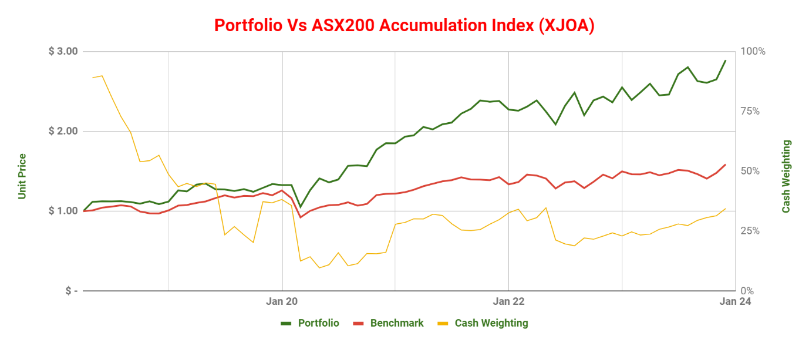
Portfolio:
Company | Initial Purchase Date | Ave. Purchase Price | Annualised Return* | Portfolio Weighting
Cash |  |  | 3.9% | 35.0%
Nick Scali | 05/07/2018 | $ 5.90 | 32.9% | 25.8%
Lovisa | 25/03/2020 | $ 7.60 | 83.4% | 17.5%
Flight Centre | 16/03/2020 | $ 13.04 | 9.3% | 11.1%
Smart Group | 20/02/2020 | $ 5.90 | 18.7% | 5.0%
SG Fleet | 27/07/2019 | $ 2.48 | 3.5% | 4.7%
Shine Corporate | 25/07/2019 | $ 0.73 | 3.3% | 1.0%
Note: For companies held for less than 12 months, the Annualised Return has been substituted with Total Return.
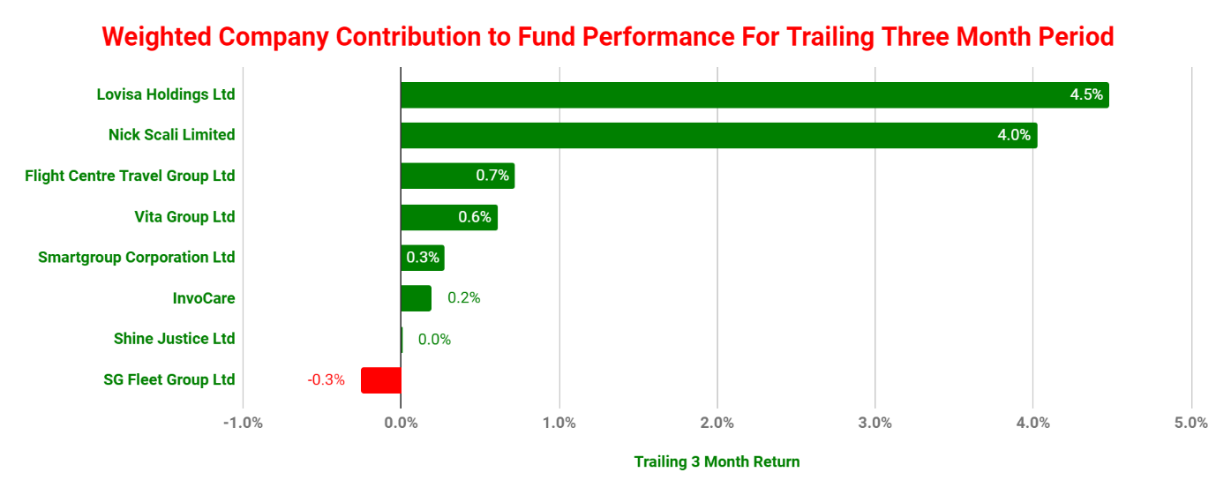
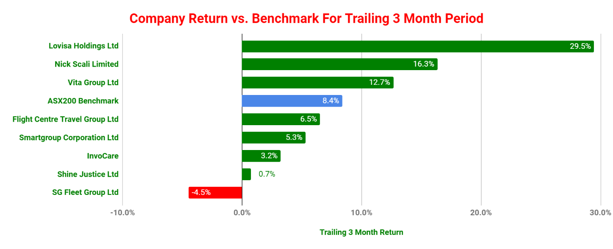
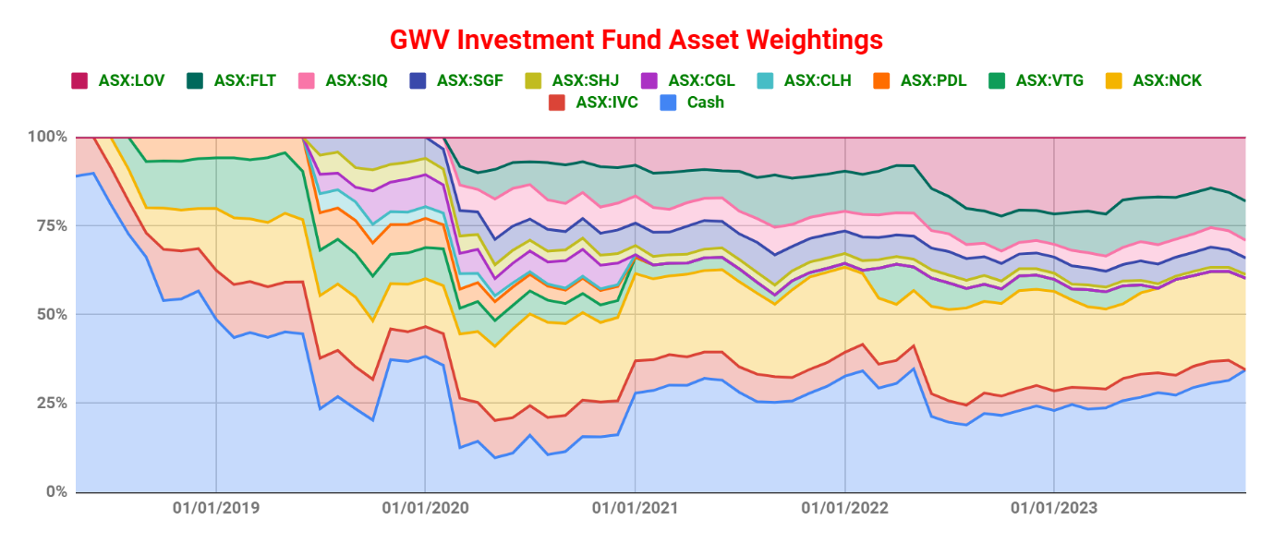
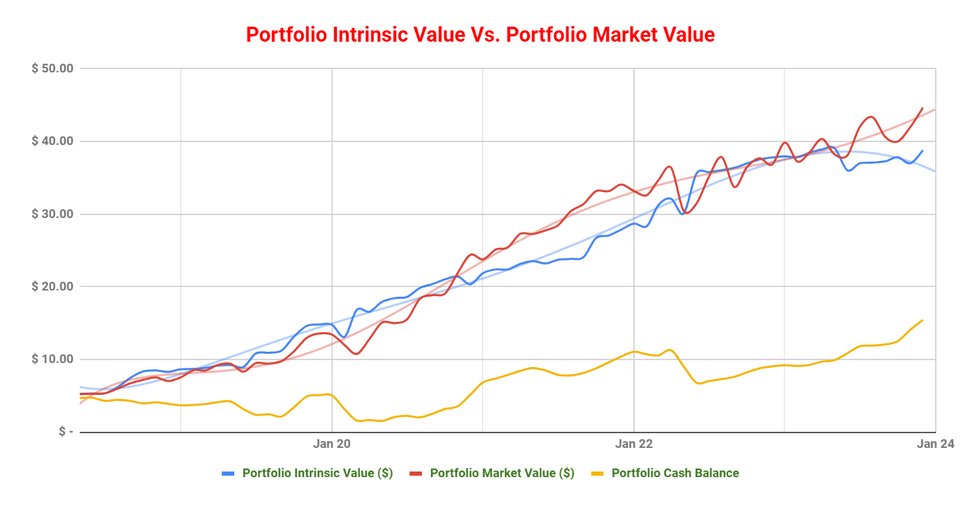
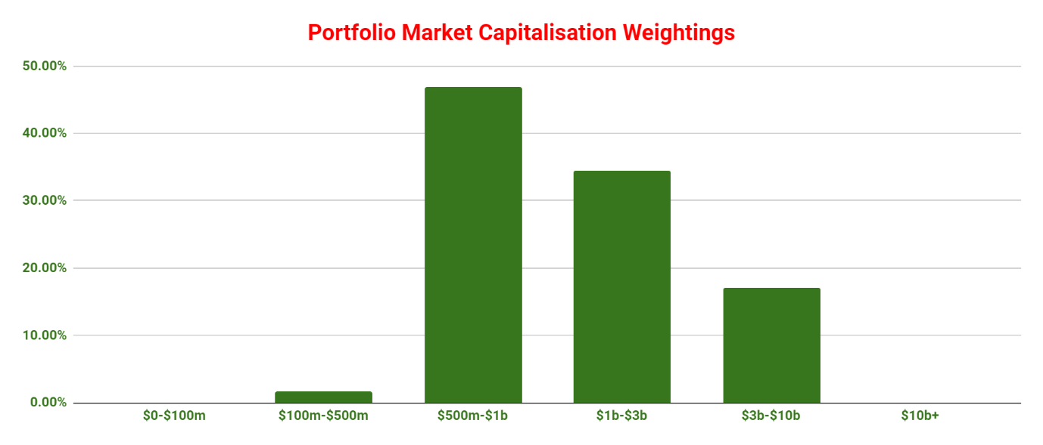
Median Market Capitalisation: 1,074 M
Weighted Average Market Capitalisation: 1,996 M
Performance:
For the Quarter ended December 2023, the Growth With Value Investment Fund returned 10.0% versus 8.4% for our Benchmark, the ASX 200 Accumulation Index (XJOA). This is an outperformance of 1.6%. At the end of this period, we held 35.0% in cash and had six open positions. We made one sale during the period, InvoCare, which was acquired by TPG.
Since its inception, the Fund has provided an annualised return of 20.6%, resulting in a total return of 189.1%. Our Benchmark has an annualised returned of 8.5%, resulting in a total return of 58.7% over the same period.
Portfolio Activity:
During the quarter, TPG completed its acquisition of InvoCare. InvoCare was our first investment and remained in our portfolio for five and a half years. Throughout this period, the investment yielded a return of 6.87% per annum. However, it is noteworthy that this performance trailed behind our benchmark, the ASX 200 Accumulation Index, which posted a return of 7.26% per annum. While the investment generated positive returns, I view it as underperforming, given the benchmark's superior performance.
It is worth mentioning that our cash allocation stands at a substantial 35%. However, this sizable cash position has not hindered our overall returns. We managed to outperform our benchmark by 1.6% for the quarter and by almost 10% for the financial year to date. Despite concerns about holding significant cash reserves, I am reassured by the flexibility it provides in the event of a market correction. I am optimistic about deploying a portion of our cash reserves in the coming 12 months.

